

Swinburne University of Technology

# Project Design Document

Marco Giacoppo (104071453)

Corey Santarossa (103389809)

Chaitanya Sood (103501933)

Tuesday 10:30

2023 Semester 2

## 1PROJECT BACKGROUND AND INTRODUCTION

Non-fungible tokens (NFTs) have revolutionised digital ownership and transformed how we perceive creativity and value in both the technology and art landscape. This fusion of blockchain's immutability, with digital art's fleeting essence has established an easily verifiable authenticity and source, offering fresh prospects for creators, collectors, and enthusiasts.

The rapid growth of the NFT market highlights the need for a specialised and proficient NFT trading platform. Online marketplaces often need more expertise to meet the unique demands of NFTs, including validating the NFT origin and safeguarding digital asset integrity. This NFT trading platform strives to be a sanctuary for creators seeking to immortalise their digital works and collectors aiming to uncover and obtain exclusive digital pieces.

Beyond the transactional features, our platform wants to develop into an immersive environment where technology and art coexist. It aims to facilitate communication between artists and collectors to promote community and engagement, like conventional art galleries.

The core of this endeavour is security. Every NFT's origin, ownership history, and metadata are kept tamper-proof and transparent thanks to blockchain technology. Smart contracts revolutionise how artists are paid for their work even after the initial sale by enabling automated royalty payments whenever their NFTs change hands. Embracing decentralised storage solutions also guarantees the preservation and accessibility of digital assets without reliance on a single point of failure.

The democratisation and decentralisation of the NFT space depends heavily on the user experience. Both experienced blockchain artists and tech-savvy collectors will be able to navigate the platform thanks to its user-friendly interface. The platform might offer educational materials to close the information gap and give users the confidence they need to conduct NFT transactions. Additionally, seamless integration with different cryptocurrencies for transactions guarantees a hassle-free user experience for users everywhere.

The proposed trading platform aims to be at the cutting edge of innovation as the NFT ecosystem develops. It envisions partnerships with artists, creators, and technologists to explore the unknown waters of virtual reality exhibitions, AI-generated NFTs, and interoperable NFT standards that go beyond blockchain boundaries. By embracing these innovations, the platform aims to influence the digital art realm and how societies value and exchange cultural artifacts in the digital era.

In conclusion, developing an NFT trading platform is a cultural and creative movement rather than just a technological one. It creates new links between artistic expression, technology, and interpersonal interaction by bridging the gap between it and the blockchain-powered future. This project aims to contribute to the ongoing discussion about the transformative potential of NFTs and their lasting influence on our world.

## 2TEAM INTRODUCTION

We are a team of computer scientists from Swinburne University, brought together by our shared dedication to innovation and technology. As students pursuing our Bachelor of Computer Science degrees, we are excited to embark on the journey of creating an NFT trading platform that seamlessly merges the worlds of art, technology, and finance.

* Marco Giacoppo (104071453)
* Corey Santarossa (103380809)
* Chaitanya Sood (103501933)

Collectively, we bring a fusion of technical competency, design finesse, and strategic thinking to this project. With our education at Swinburne as the foundation, we are eager to learn, collaborate, and make a meaningful contribution to blockchain technology and NFTs.

## 3PROJECT REQUIREMENT LIST AND DESCRIPTION

In this section, we will provide the core requirements of this project and demonstrate our understanding of the given system requirements.

3.1PLATFORM OVERVIEW:

* Develop a user-friendly online platform that facilitates the trading of NFTs within the blockchain ecosystem.
* Provide a secure user registration and login process (using an Ethereum wallet address instead of personal data to comply with the focus of web3).
* Display a visually appealing and intuitive user interface.

3.2NFT LISTING AND BROWSING:

* Enable users to browse, discover, and explore a wide range of NFTs available for trading.
* Implement search and filter functionality for easier navigation.
* Display information about each of the NFTs, including its title and price.

3.3TRADING AND MARKETPLACE:

* Facilitate the buying, selling, and trading of NFTs among users.
* Implement fixed price NFT transactions.
* Allow users to view their history. 3.4SECURITY AND PRIVACY:
* Prioritize the security of user data and transactions.
* Implement encryption for sensitize user information.
* Conduct regular security audits and updates.

3.5RESPONSIVE DESIGN:

* Ensure the platform is accessible from different devices and screen sizes.
* Design a responsive layout that adapts to mobile, tablets, and desktop screens.

3.6FUTURE SCALABILITY:

* Plan for future expansion and growth of the platform.
* Develop a modular and scalable architecture increased user traffic and new features.

## 4PROJECT DESIGN

This part comprises two sections. The first section will describe our front-end prototype sketches and design drawings, while the next section will offer a high-level overview of our system architecture.

### 4.1FRONT-END PROTOTYPE – LANDING PAGE

Our landing page features a navigation bar for accessing different page sections. Additionally, we've designed the website to be responsive across various devices.

*Figure 1: Homepage Wireframe*

*Figure 2: Homepage Desktop*

*Figure 3: Homepage Mobile*

### 4.2FRONT-END PROTOTYPE – BROWSING PAGE

Users can quickly discover the currently popular NFTs on this page by sorting them based on their names and prices. Furthermore, users will have the capability to search for specific NFTs using their names.

*Figure 4: Browsing Page*

*Figure 5: Browsing Desktop*

*Figure 6: Browsing Mobile*

### 4.3FRONT-END PROTOTYPE – CHECK OUT PAGE

On this page, the user's NFTs are showcased within the cart, offering the ability to purchase and proceed to checkout. Users have the flexibility to add or remove items from the cart, and the total cost is displayed for their convenience.

*Figure 7: Checkout Page*

*Figure 8: Checkout Desktop*

*Figure 9: Checkout Mobile*

### 4.4FRONT-END PROTOTYPE – ABOUT US PAGE

This page aims to provide the user with insights towards NFTs with two focuses in particular; what they are and how they are used. Furthermore, this page delivers a short introduction to the NFTplace brand.

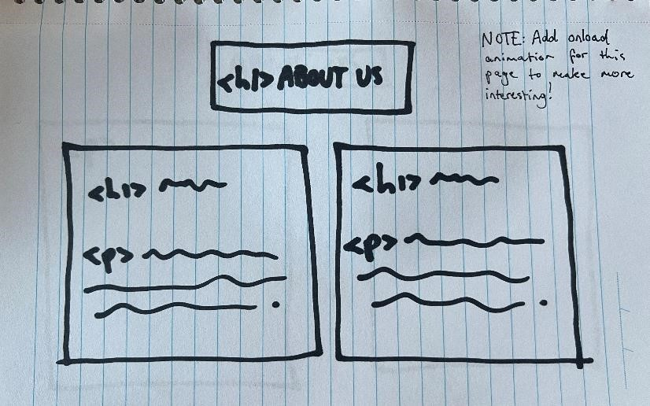

*Figure 10: About Us Page*

*Figure 11: About Us Desktop*

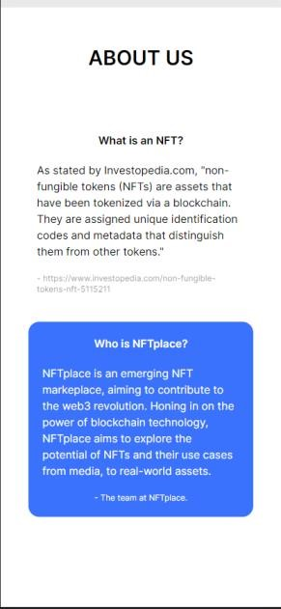

*Figure 12: About Us Mobile*

### 4.5FRONT-END PROTOTYPE – CONTACT PAGE

The contact page contains a form where the user can input contact information and a query, where the query can then be sent to a predefined email address. This will be complete once a backend is configured.

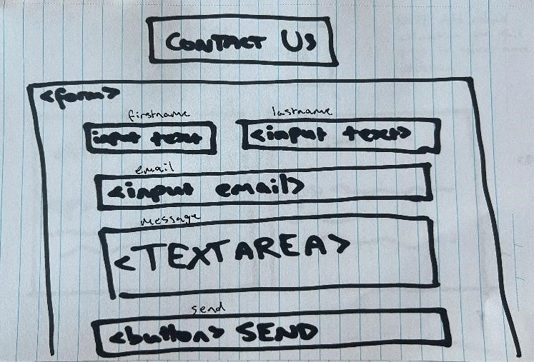

*Figure 13: Contact Page*

*Figure 14: Contact Page Desktop*

*Figure 15: Contact Page Mobile*

### 4.6FRONT-END PROTOTYPE – TRANSACTION HISTORY PAGE

Finally, the transaction history page is opened by selecting the clock icon (a common theme in web3 dApps), where the users transaction history is displayed in a modal. This modal contains the time of transaction, the contract address and a link to etherscan.

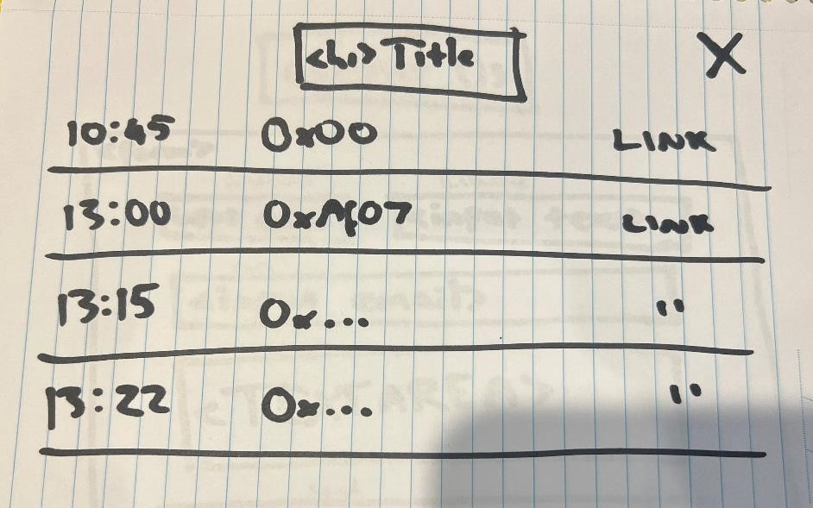

*Figure 16: Transaction History Page*

*Figure 17: Transaction History Desktop*

*Figure 18: Transaction History Mobile*

### 4.7OVERALL SYSTEM ARCHITECTURE DESIGN

Users will see a landing page with four sections: Home, NFTs, About, and Contact. The "Browse NFTs" button allows users to select the NFTs they want to add to their shopping cart. Below are two supporting images representing the underlying system architecture of this project.

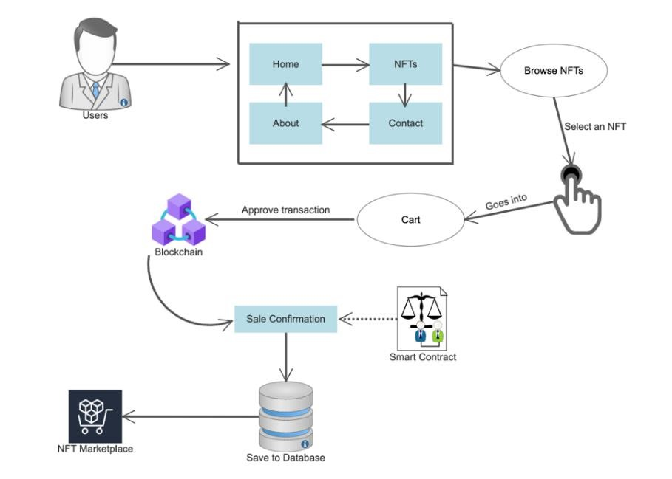

*Figure 16: Overall System Architecture Design*

*Figure 17 – A high-level overview of the processes occurring during the initiation and completion phases of a smart*

*contract.*

### 4.8 BACKEND DATABASE DESIGN

#### 4.8.1 Database Structure

Our backend database design plays a crucial role in storing and managing data for our NFT trading platform. Below is an overview of the key database tables and their relationships:

**Contact Form Table:**

* `form_id` (Primary Key)
* `first_name` (varchar)
* `last_name` (varchar)
* `email` (varchar)
* `message` (varchar)

**NFT Table:**

* `id` (Primary Key)
* `title` (varchar)
* `price` (decimal)
* `image` (varchar)

**Order Table:**

* **`**order_id` (Primary Key)
* **`**purchased_nft_ids` (Foreign Key)
* `signer_address` (varchar)
* Total_eth (decimal)
* `time` (datetime)
* `hash` (varchar)

#### 4.8.2 Database Management

We use the PhpMyAdmin server as our relational database management system (RDMBS) to ensure data integrity and robustness. It enforces referential integrity constraints between tables, enhancing data consistency.

#### 4.8.3 API Integration

The backend communicates with the frontend through a set of well-defined APIs. These APIs allow for Creating and reading operations on user accounts, transactions, and carts.

### 4.9 API DESIGN

#### 4.9.1 Endpoints

Our API endpoints are developed using ExpressJS. Here are all the API endpoints:

The URL for each endpoint is *http://localhost:8080/<endpoint>*

* `GET /nfts`: Retrieve a list of available NFTs.
* `POST /search`: Searching the database
* `GET /sortAZ `: For sorting NFTs from A - Z
* `GET /sortZA `: For sorting NFTs from Z - A
* `GET /sortCheap`: For sorting NFTs from low price to high.
* `GET /sortExpensive`: For sorting NFTs from high price to low.
* `POST/contact`: For posting the new messages sent from the frontend.

#### 4.9.2 Data Structures

Our APIs use JSON for data exchange. Below are shortened versions of the responses.

For the /search API endpoint, the frontend sends the letters typed as shown in the request body

**REQUEST (POST /search):**

*{*

*“title”:”b”*

*}*

After receiving the request, it sends a response with all the items with that title to the frontend with the **STATUS CODE: 200 OK** as everything is working.

**RESPONSE (POST /search):**

*{*

*"data":[*

*{*

*"id":4,*

*"title":"CUBE",*

*"price":"0.60",*

*"image":"https://images.unsplash.com/photo-1673235966910-f2a443bdbaaf?ixlib=rb-4.0.3&ixid=M3wxMjA3fDB8MHxwaG90by1wYWdlfHx8fGVufDB8fHx8fA%3D%3D&auto=format&fit=crop&w=1964&q=80"*

*},*

*{*

*"id":6,*

*"title":"SUB",*

*"price":"0.50",*

*"image":"https://images.unsplash.com/photo-1685570103029-b4742961df08?ixlib=rb-4.0.3&ixid=M3wxMjA3fDB8MHxwaG90by1wYWdlfHx8fGVufDB8fHx8fA%3D%3D&auto=format&fit=crop&w=1974&q=80"*

*},*

*{*

*"id":8,*

*"title":"BMW",*

*"price":"0.70",*

*"image":"https://images.unsplash.com/photo-1675426513962-1db7e4c707c3?ixlib=rb-4.0.3&ixid=M3wxMjA3fDB8MHxwaG90by1wYWdlfHx8fGVufDB8fHx8fA%3D%3D&auto=format&fit=crop&w=2070&q=80"*

*},*

*{*

*"id":11,*

*"title":"BRIGHT",*

*"price":"0.00",*

*"image":"https://images.unsplash.com/photo-1686452975139-bbb8846dd7e9?ixlib=rb-4.0.3&ixid=M3wxMjA3fDB8MHxwaG90by1wYWdlfHx8fGVufDB8fHx8fA%3D%3D&auto=format&fit=crop&w=1964&q=80"*

*}*

*],*

*"status":200,*

*"statusText":"OK",*

*"headers":{*

*"content-length":"866",*

*"content-type":"application/json; charset=utf-8"*

*},*

*"headers":{*

*"Accept":"application/json, text/plain, */*",*

*"Content-Type":"application/json"*

*},*

*"baseURL":"http://localhost:8080",*

*"method":"post",*

*"url":"/search",*

*"data":"{\"title\":\"b\"}"*

*}*

*}*

Below is the request to insert the details of the contact form once it is submitted.

**REQUEST (POST /contact):**

*{*

*"firstName": "John",*

*"lastName": “Doe”,*

*"email": “*[*johndoe@gmail.com*](mailto:johndoe@gmail.com)*”,*

*"message": “Hello there!”,*

*}*

And when using the /nfts API endpoint, we get the following response with **STATUS: 200 OK** from the GET request. Below is a shortened version of the response for demonstration.

**RESPONSE (GET /nfts)**

*{*

*"data”: [*

*{*

*"id":11,*

*"title":"BRIGHT",*

*"price":"0.00",*

*"image":"https://images.unsplash.com/photo-1686452975139-bbb8846dd7e9?ixlib=rb-4.0.3&ixid=M3wxMjA3fDB8MHxwaG90by1wYWdlfHx8fGVufDB8fHx8fA%3D%3D&auto=format&fit=crop&w=1964&q=80"*

*}*

*],*

*"status":200,*

*"statusText":"OK",*

*"headers”: {*

*"Content-length":"2295",*

*"content-type":"application/json; charset=utf-8"*

*},*

*"headers”: {*

*"Accept":"application/json, text/plain, */*"*

*},*

*"baseURL":"http://localhost:8080",*

*"method":"get",*

*"url":"/nfts"*

*}*

*}*

All the other GET requests to our sorting API endpoints return the response in a similar format with the order of the ‘data’ array changed according to the sorting option.

#### 4.9.3 HTTP Methods

Our API adheres to standard HTTP methods:

* GET: Retrieve data.
* POST: Create new resources.

### 4.10 FUNCTION DESCRIPTION

Example: Buying an NFT

To demonstrate our platform’s functionality, let’s walk through the process of buying an NFT.

1. Browse NFTs: Users explore a wide range of NFTs by clicking on the “NFTs” section.
2. Select an NFT: When a user finds an NFT they wish to purchase, they click on it to put it into the cart.
3. Initiate Transaction: The frontend initiates a transaction to purchase the product using ether.js. The price is fetched from MySQL, and then converted into wei. Finally, ethers.js passes this integer from the frontend to the smart contract which is deployed on Remix.IDE.
4. Contract Verification: If all requirements are met, the smart contract executes the transaction and returns the receipt upon completion.

## 5 PROJECT DEPLOYMENT INSTRUCTION

## In this section, we will provide step-by-step deployment instructions for our NFT trading platform, including configuration settings, dependencies, and environmental requirements. Please refer to the separate deployment documentation for detailed guidance.

### Deployment Steps:

1. Database Setup:

* Ensure XAMPP is installed and running.
* Import the database schema from the provided SQL dump.
* Turn on Apache and MySQL in XAMPP.
* Access PhpMyAdmin and refer below for step-by-step instructions.

You need to create a database named **‘s104071453’** at the start.

Figure 8 - Creating DB

Once you have created the database, you need to select the database and click import.

Figure 19 – Clicking the Import button.

Now, you just need to import our database and click import.

Figure 20 - Importing Database

1. Backend Deployment (Node.js):

* Make sure you have node installed and are in the correct directory while running commands.
* Run in the command line *“npm install”* in the **Backend Directory** to install the required packages.
* Run *‘’npm run dev’’* in the **Backend Directory** to start the node server.

1. Frontend Deployment:

* Make sure you are in the correct directory while running commands.
* Run in the command line ‘’*npm install --force*’’ in the **Frontend Directory** to install the required packages. Since react 18 has less compatibility with MUI v4
* Run *‘’npm start‘’* in the **Frontend Directory** to start the website.

1. (Optional) Smart Contract Redeployment:

Note: The smart contract is already deployed, but if you wish to deploy your own copy, perform the following steps:

* OPEN <https://remix.ethereum.org/>
* Create new file called ‘’**NFTcontract.sol**’’
* Paste the code in frontend -> src -> smartcontract -> nftContract.sol
* Select the injected provider (metamask)
* Compile the contract.
* Deploy the contract and pay the gas fees as required.
* Copy the contract address and paste in frontend -> src -> assets -> components -> Cart.jsx under the “contractAddress” variable. The ABI is already copied into the code and does not need to be changed unless contract is modified.
* Refer to Frontend Deployment to start the website.

## 6 CONCLUSIONS

In summary, NFTs have truly reshaped the digital landscape, sparking a revolution in how we perceive art and value in the modern era. This fusion of blockchain's immutability with the transient nature of digital art has opened new doors for creators, collectors, and enthusiasts alike.

As the NFT market keeps growing, there's a need for a dedicated and reliable platform. Regular online marketplaces often struggle to meet the unique needs of NFTs, like confirming the origin and ensuring digital assets' integrity. Our NFT platform aims to be a safe space for collectors looking for one-of-a-kind digital treasures and artists wanting to preserve their digital creations.

Aside from buying and selling, our platform wants to create an engaging environment where technology and art coexist peacefully, encouraging interaction between artists and collectors, similar to what you'd find in traditional art galleries. Our top priority is security. We use blockchain to track where each NFT comes from, who's owned it, and its details. Smart contracts are crucial because they automatically pay artists a share every time an NFT is sold, ensuring they keep getting compensated. We also use decentralized storage to make sure digital assets are always accessible and don't depend on a single point of failure.

Making the platform user-friendly is essential to make NFTs accessible to more people. We've created educational resources to bridge the knowledge gap and build trust in NFT transactions. Our interface is easy to use for both experienced blockchain artists and tech-savvy collectors. Plus, we make it easy for users worldwide by supporting various cryptocurrencies.

Looking ahead, we want to keep leading in NFT innovation. We aim to explore new areas like virtual reality exhibitions, AI-generated NFTs, and NFT standards that work across different blockchains. We plan to collaborate with artists, creators, and tech experts to redefine the digital art world and change how society views, values, and trades cultural artifacts in the digital age through these exciting projects.

In the end, our NFT platform isn't just a tech development; it's a creative and cultural movement. It connects artistic expression, technology, and human interaction, bridging the present with a blockchain-powered future. This project is our way of contributing to the ongoing discussion about the game-changing potential of NFTs, which will forever alter the course of human history.

## 7REFERENCES

Bansal, M. (2022). How to design & then develop an NFT Marketplace — Understanding the Architecture behind it! [online] Coinmonks. Available at: https://medium.com/coinmonks/how-todesign-then-develop-an-nft-marketplace-understanding-the-architecture-behind-it-bdeb8af9fbc2 [Accessed 26 Aug. 2023].

DBInvesting, A. (2023). What are NFTs? How They Can Change the World. [online] dbInvesting. Available at: https://dbinvesting.com/blog/the-rise-of-nfts-how-non-fungible-tokens-are-changingthe-art-world/ [Accessed 26 Aug. 2023].

Sharma, R. (2023). *Non-Fungible Token Definition: Understanding NFTs*. [online] Investopedia.

Available at: https://www.investopedia.com/non-fungible-tokens-nft-5115211.

**System Architecture Images (created in Figma)**

* MetaMask Logo: https://commons.wikimedia.org/wiki/File:MetaMask_Fox.svg# (Accessed 15/08/23)
* Ethereum Logo: https://www.pngall.com/wp-content/uploads/10/Ethereum-Logo-PNG-HDImage.png (Accessed 15/08/23)
* Solidity Logo: https://commons.wikimedia.org/wiki/File:Solidity_logo.svg (Accessed 15/08/23)
* SQL Logo: https://www.pngwing.com/en/free-png-zoupl/download (Accessed 15/08/23)
* React Logo: https://www.cleanpng.com/png-react-javascript-angularjs-ionic-atom2904925/download-png.html (Accessed 15/08/23)
* Node Logo: https://www.pngwing.com/en/free-png-nmhof (Accessed 15/08/23)